Daily Tip 10 30/04/2003 02:00:00 PM

Animated GIFs
SAS/Graph allows us to create animated GIF files. These files can contain a number of graphs in the one file. When displayed through an application which supports them, we can see the graphs one by one. We can also define whether the sequence repeats and how long between each image.
For some nice examples of animated GIFs & the code to produce them - http://support.sas.com/rnd/samples/graph/gifanimoverview.html

SAS Program
filename anim 'c:\anim.gif' ; /* file to create */
goptions device=gifanim /* animated GIF driver */
gsfname=anim /* fileref to save file to */
delay=100 /* 1/100s of a second between each image */
gsfmode=replace /* wipe over previous file */
disposal=background ; /* when graph is erased background color returns */
proc gchart data=sashelp.prdsale ;
vbar3d prodtype ;
run ;

goptions gsfmode=append ; /* append the next graph to existing image */
proc gplot data=sashelp.class ;
plot height*weight ;
run ;

goptions gepilog='3b'x; /* write end-of-file character after next graph */
proc gchart data=sashelp.prdsale ;
hbar3d country ;
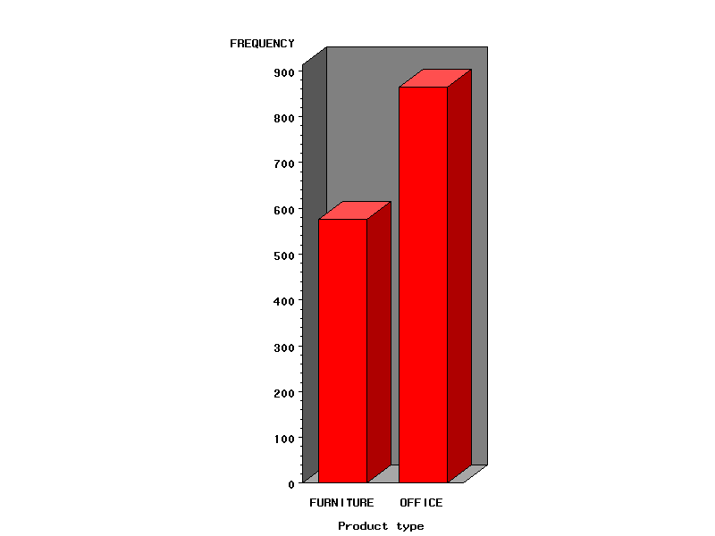
Example tested under SAS 9.0, Windows 2000 by Phil Mason
Wood Street Consultants Ltd. tips@woodstreet.org.uk
www.woodstreet.org.uk

